4a Stop Time
Stop time rounded = 33,333 ps

4c Scan Stop and Observations
I kept the scan stop time the same as calculated above.
I started to see my reflection at approximately 17 ns.

5bi Target Distance
77 inches

5cii Plots
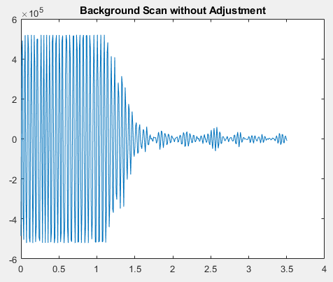
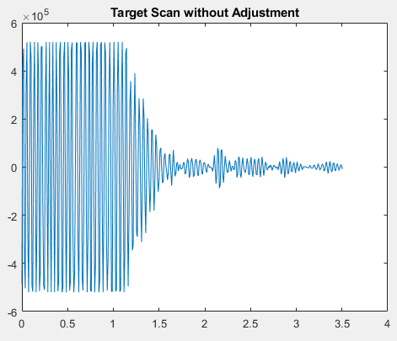

5cii Observations
Both plots have remarkably similar shapes. The largest difference is a small spike in the target plot at roughly 2.3 meters corresponding to the location of the target.

5ciii Plot
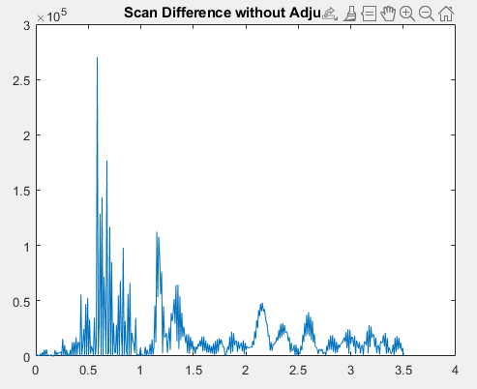
I was working with a lot of noise in the background. The first peak at 0.5m is most likely a labmate’s chair getting in the way. The second peak at 1.2 m is the target. The third peak at 1.35 m is a table.

5di Start Time
Start time = 10,000 ps

5dii Stop Time
Stop time rounded = 34,267 ps
5d Plot
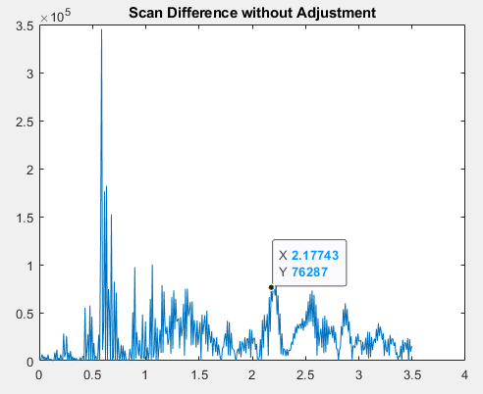
The peak at 0.6 m is noise, possibly myself standing in the way or a desk chair. There is no noticeable item in the path of the radar at approximately 0.6 m. The same can be said for the peaks between 0.9 m and 1.5 m. The peak at 2.17 meters is the target. The peak at 2.5 m is likely the table in the middle of the lab. The peak at 2.7 m is likely the target of the person at the computer opposite me.

Questions
- The residual clutter in the scan difference plot has many possible sources. The noise could be coming from any number of objects that randomly come into view. Additionally, error in the system or an incomplete background scan can add additional noise.
- The following MATLAB commands were used for 5c(iv):
[a,i]=max(scan_difference(10,:));
distance=Rbin(i)

